Science 9 Course Outline
Valleyview Secondary School

Teacher: Ms. B. Turner
bturner@sd73.bc.ca

Core Competencies for Science 9:

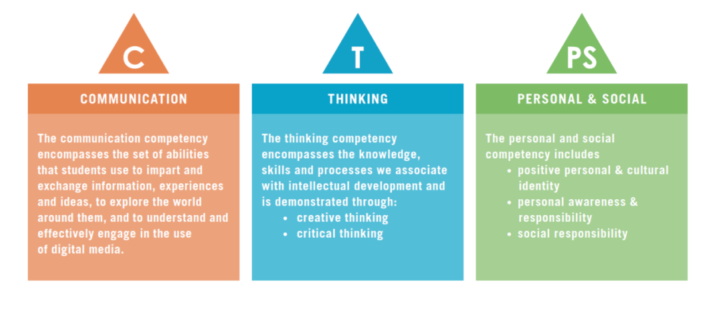

Big Ideas:

- Cells are derived from other cells
- The electron arrangement of atoms impacts their chemical nature
- Electricity is the flow of electrons
- The biosphere, geosphere, hydrosphere and atmosphere are interconnected, as matter flows through them

Learning Standards
Curricular Competencies | Content
Students are expected to be able to do the following:  - Questioning and Predicting  - Planning and Conducting  - Processing and Analyzing Data and Information  - Evaluating  - Applying and Innovating  - Communicating  At and increasing level of complexity throughout the course | Students are expected to know the following:  - Asexual Reproduction  - Sexual Reproduction  - Element properties as organized in the periodic table  - An element’s properties are related to the arrangement and energy of its electrons and to its atomic size  - Circuits must be complete for electrons to flow  - Voltage, current and resistance  - Effects of solar radiation on the cycling of matter and energy  - Matter cycles within biotic and abiotic components of ecosystems  - Sustainability of systems and First People’s principles of interconnectedness

Materials Required:

Textbook (BC Science 9 Connections)
Pencil, pen, pencil crayons, ruler
Binder with lined paper
Workbook $10

Student Expectations:

- The classroom will be a positive learning environment. Respect the people and the things around you. Any behaviour disrupting your learning or the learning of others will not be tolerated.

- Be on time, with necessary materials and ready to work BEFORE the second bell.

- Assignments will be completed by a specified date; otherwise students will be required to attend tutorials at lunch.

- Missed tests and quizzes will be made up on the first day back to school, and ONLY if the absence is excused.

- No food or drink is allowed in class. Water in a closed container is acceptable.

- I am available for help either at lunch or after school. It is up to you to ask for this extra instruction. Do not hesitate – get help quickly before you get overwhelmed and frustrated!

Assessments:

In this course students will be assessed on the content and competencies above. The primary tools of assessment will be tests, projects, quizzes and assignments. Students will be given multiple opportunities to demonstrate their content knowledge and their ability to apply the curricular competencies.

Topic | Percent of Grade (subject to change)
Cells: Reproduction | 30%
Electron Arrangement | 30%
Electricity | 20%
Spheres: Cycles | 20%

Rewrites may be requested if a student scores lower than 50% on a test.

Effort mark will be determined based on student attendance, preparedness, participation, on task behaviour, attitude and assignment completion. The effort rubric can be found on our school website: http://www.vss.sd73.bc.ca

Grades are posted on MyEd and can be seen at anytime.

Cell Phones/Smartphones/Electronic Devices

Technology is a part of our world, and can be a very useful tool in the classroom. However, inappropriate use (texting, phone calls, taking pictures, social media) will not be tolerated. You will be given a warning on first offense. On second offense the device will be taken away and given back at the end of class. If this becomes an issue, it will go to the office to be resolved.

Please take this course outline home and review it with your parents or guardians. Once reviewed, please sign below and return this page to Ms. Turner.

Student: I have read an understood the course outline and expectations.

Student Name: ____________________________________ Date: ________________________

Parent/Guardian: I have read the course outline and expectations.

Parent Name: _____________________________________ Date: ________________________

Parent Email: _____________________________________

